CHT Series, Short Tube, Down Pins

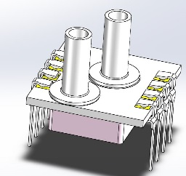

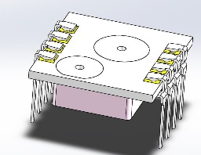
CHT Series, No Tube, Down Pins

CHT Series, Long Tube, Down Pins
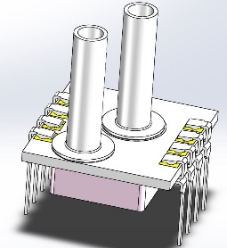

CHT Series, Short Barb, Down Pins
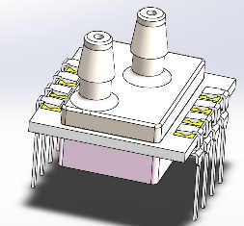

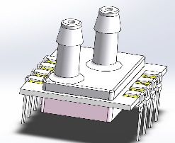
CHT Series, Long Barb, Down Pins

CHT Series, Short Tube, Up Pins

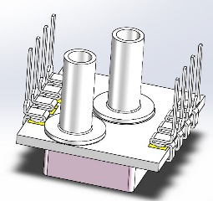

CHT Series, No Tube, Up Pins
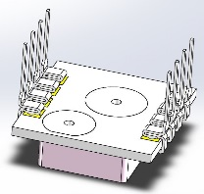

CHT Series, Long Tube, Up Pins

